Moving On

Getting ready to transfer form Primary School to Secondary School.

From…
My Primary School:

To…
My new Secondary School:
_______________________________________


Presently many of our schools are not working as normal due to a virus call COVID-19. This is to keep everyone safe.
No-one yet knows when and how schools will be re-opening.
Things may be different when this happens, but your schools will let pupils and parents know.

Starting Secondary School is an exciting time. It is also a time when there are bound to be changes. Everyone who is starting Year 7 will be feeling nervous, and that is OK. It is completely normal to feel anxious about changes especially big ones. Knowing what to expect, talking about your worries and having a plan to manage anything that seems difficult can make changes a lot easier to cope with.

There will be lots of things that are different at your new school, but you may be surprised at how much will be very similar or the same.
This workbook will help you prepare to leave your primary school and move on to your new Secondary School.

Finding out about my new school
Name and address of my new school:
My house name is:

My house colour is:

My form name is:

My form tutor is:
Photo of new school
Phone number:
Email:
Website:
Headteacher:
School starts at:

Break starts at:

Lunch starts at:

School finishes at:


Stick photos of staff members, classrooms, key areas and ‘landmarks’ within school to help you remember important people and places.
My Form Room
My Form Tutor
SENDCo

Support Staff
Support Staff
Head Teacher



Look on your new school’s website to find out more information.

What 3 things can you find out about the school?

What am I going to learn about in Year 7?




- What other questions would you like answered?
- Write a letter to your new school with a list of anything you would like to know about going to your new school and any pictures that you would like of your new school. Your letter will be sent to the school for them to answer your questions.


Other things to find out:

Questions | Answers
General:
Who will I go to if I need help during the school day?
Who can explain the different school rules to me?
If I arrive late to school what do I need to do?
If I have to bring medication into school, who do I give it to?
If I feel unwell who do I tell?
Can I use my phone in school?
How do I know where to sit in class?
Can I choose my seat to be near the door/window, at the back/front, next to my buddy?
Do I have any 1:1 time, and if so, how many hours a week?
If I find it hard to ask for help in class what can I do?
Homework:
How much homework will I get?
What should I do if I lose it, forget to complete it or don’t understand what to do?
How long am I expected to spend on each piece?
Is there a homework club?

Other things to find out:

Questions | Answers
Break/lunch time
What food choices are there?
How do you pay for food?
Where can you eat?
Where do the packed lunches go?
Is there somewhere quiet that I can go?
Add your own questions below:


Write down things that you are looking forward to when you start your Secondary School.



Feelings about my new school
 |    |  |  | 
School Uniform
Getting to school
Being on time
Different kinds of lessons
More clubs
Moving to different classrooms
Finding my way around
Busy, noisy corridors
Having different teachers
Harder work
Homework
Organising my bag and school equipment
Being responsible for my things
Break and lunch times
Using the toilets
More people
Missing old friends
Making new friends
Being bullied
Who to ask for help
Getting in trouble
Detentions
Knowing where to sit in each class
Using a locker
School or house assembly
Changing for PE
Learning a new timetable
Sorting things out!
What are my three main worries?
Think of two plans for each one to help the worry go away.

Plan 1
Plan 2
Plan 2
Plan 2
Plan 1
Plan 1
Making new friends
At secondary school there will be students from other schools. There will be opportunities to make new friends. It can be difficult to get to know someone new.
It may help to act out meeting new people and use some of these suggestions:
- Smile when you say ‘Hello’
- Start the conversation by asking a question about what they are doing. ‘What are you doing?’ or ‘What are you reading?’ Or something you have in common ‘So how do you like this lesson?’
- Introduce yourself – ‘By the way my name is ______, what’s yours?
- Ask some other questions to find out about them. Suitable topics may be:
School – What lessons do you like? Who is your teacher?
Home – Where do you live? How do you get to school?
Interests – What do you like doing? What’s your favourite TV programme?
Family – Have you got any brothers or sisters?
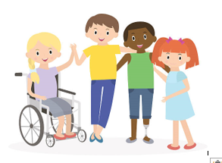
- If they answer your question respond to some of the information, they have told you. If you can, ask another question. ‘That’s my favourite lesson too. I enjoyed working on the computers. What did you like doing?

Making new friends

Other students may want to ask you questions about yourself?

What questions do you think they might ask?

How might you answer their questions?

What would you like your new friends to know about you?

How would you like your friends to help you?

How would you ask them?

Joining-in
Joining in conversation or a group activity can be scary. However, it is one way to make new friends. Try these strategies for joining in.

Watch and listen. Observe what the group is going. Listen to what the people are saying. Don’t interrupt

Make a friendly comment or gesture. Nod your head and smile. Make comments like, ‘that’s a good idea’, or ‘that looks great’

Find something you have in common with the group. Think about your own experiences. You could say, ‘I saw that movie’, or ‘I have that game at home’. Keep your comments short.

Ask to join the group. Wait for a pause in the conversation. You could say, ‘can I walk with you?’ ‘Do you need any help’ or ‘can I play?’

Accept ‘no’ for an answer. Sometimes people don’t want you to be part of the group. Don’t argue or complain. Go and ask someone else.






Joining-in Situations
Here are some situations you might want to join in with. Try and plan what you may say or do. You could try acting these situations out.

- You see three of your classmates playing football after school. You know one of them pretty well. You don’t know the other two. How could you join the game?
What could you do? ____________________________________
What could you say? ____________________________________

- You hear two classmates talking about the latest PlayStation game. You were playing on it last night.
What could you do? ____________________________________
What could you say? ____________________________________

- You have found out there is an IT or Music club at lunch times. You would really like to join.
What could you do? ____________________________________
What could you say? ____________________________________

- You would really like one of your new friends to come to the club with you.
What could you do? ____________________________________
What could you say? ____________________________________

- Four classmates are looking at a text message they have received from a friend. They are laughing. You’re sitting at the same lunch table. You like sending text messages.
What could you do? ____________________________________
What could you say? ____________________________________

School Uniform
What will your new school uniform be like?
Is there anything you need to practice or need support with?
- Tying a tie?
- Changing quickly for PE?
- Tying shoelaces?

List some of the clothes you might wear to school. Remember to think about appropriate shoes.
1. _________________________________________
2. _________________________________________
3. _________________________________________
4. _________________________________________
5. _________________________________________

You will need different clothing for PE. Make a list:
1. _________________________________________
2. _________________________________________
3. _________________________________________
4. _________________________________________
5. _________________________________________
6. _________________________________________

Make sure you buy a bag that can hold A4 folders, textbooks, equipment and is comfortable to carry. It needs to be as light as possible, preferably a rucksack.

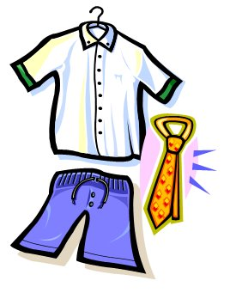
Succeeding in Secondary School
This is for you to say how you feel so that the teachers and staff can help you.
Issue | Always | Sometimes | Never | Notes:
It takes me a long time to get up and dressed in the mornings
It is hard for me to get up and down steps and stairs
Sitting on the floor is painful or difficult
I cannot get up from the floor very quickly
I need help taking off my coat/shoes/hat
I need help getting changed for PE
I feel tired during the day

It helps if I can leave class early to avoid the rush
I need someone to help me catch up on things if I’ve been off school
I need someone to help me keep up in class with my writing
I am unable to stand in line for a long time
My joints are painful

I need to wear splints or use mobility aids at school
I need to take medication at school
I need to be reminded to take my medication
My medication makes me feel drowsy / sick
I need to do physiotherapy/ sensory circuits at school
I need to do a fine motor programme at school
I need to rest when I get home
I need help writing up my homework
I use a computer to record my work
I need help with turning taps and handles (eg doors, wash basins)
I find it hard to use a pen, pencil or paintbrush
I find it difficult to do practical lessons (eg food tech, science practical, textiles)
Raising my hand in class is difficult
It is difficult to carry things and walk (eg lunch tray, school equipment, bags)
I need to get up and walk around during class because I get stiff
I need more time to get from class to class

I find it difficult to reply quickly when I’m asked a question
I have a laptop at home.

Succeeding in Secondary School
This is for you to say how you feel so that the teachers and staff can help you.

- What would you like the adults at your new school to know about you?

- Who would you like to know, all staff or just the ones who will be working closely with you?

- How would you like adults to help you?

- How would you like your friends to help you?

- What works well for you?

- What doesn’t work well for you?

- What are you good at and enjoy?

- Would you like to write it down or make a power point presentation that could be shared with teachers and support staff?





How will you travel to school?
On foot
Route:

Walking with:
Journey time:
Leave home by:
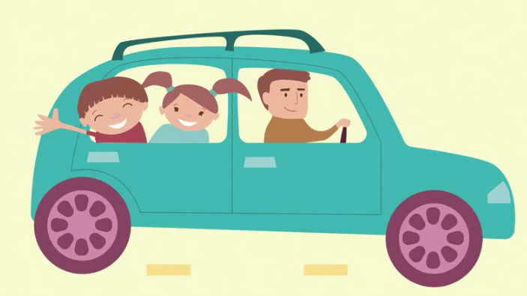

By car
Driver:
Drop off point:
Journey time:
Leave home by:
Collection point:
Meet by:

By Taxi
Driver:

Drop off point:
Journey time:
Leave home by:
Collection point:
Meet by:



By bus
Bus number:
Get on at:
Get off at:
Journey time:
Leave home by:

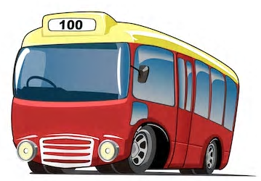

Home Help

Give this sheet to your mum or dad, or whoever helps you get ready for school.
Ideas for helping your son/daughter at home.
Talk
Encourage your son/daughter…
- To talk about school – likes/dislikes, what they are good at, what they are worried about…
- To talk about books, films, hobbies etc.
Don’t pressure tem they will talk when they are ready.

Organisation
- Encourage them to make a large copy of their timetable
- Display it in a prominent place
- Refer to it to remind them what lessons they have each day
- Make lists of what they need each day
- Encourage them to pack their bag with everything they need for the next day
- Don’t pack their bag for them
- Encourage them to get into a routine and do things in a similar sequence
Coursework
- Help plan out extended pieces of coursework over a period of days or weeks
- Check their homework diary each day
- Encourage them to have a set time to
do their homework
- Help with homework
- Don’t do their work for them
- Keep an eye on the time they spend on
their work. Check they do not spend too long
or too little time on each piece.

Coping with Changes

Every day you deal with many small changes in your routines like going from being at home to being in school, changing between lessons and having different teachers. Sometimes there are unexpected changes such as your mum bought a different cereal for breakfast, your teacher swaps the lessons around, your friend is away or you have a supply teacher.
When the changes have happened before, you know what to expect and you can make a plan. If it is a change which you have not had before it can make you worry about what will happen next.

What plan can you make?

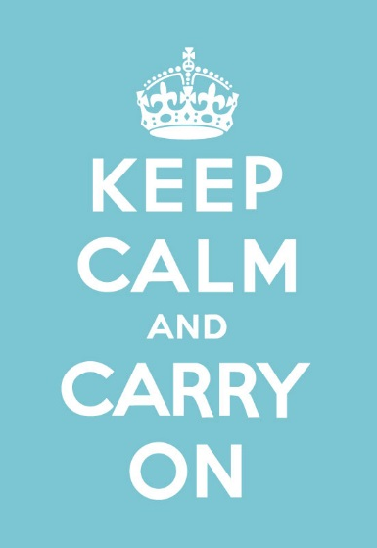

Preparing your first day
What do you need to get ready?
Make you plan here:

- School clothes
- Equipment for learning
- Personal equipment
- Food and drink

What am I going to say when I meet my new form tutor?

What am I going to say when I meet my new form tutor?

