E-Safety Scenarios
Scenario 1:  Your friend has been talking to someone online. He/She tells you they’re going to meet up tomorrow. | 
Scenario 2:  A friend has sent you a mean message through the school email. | 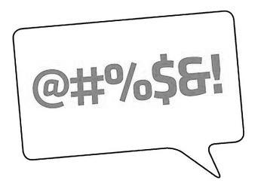
Scenario 3:  You’ve been playing an online game and someone you don’t know asks to be your friend. | 
Scenario 4:  You notice a rude picture has been uploaded to a website you use. | 
Scenario 5:  Your friend has sent you an email with an attachment of a rude picture. | 
Scenario 6:  You keep lying to your mum about going onto a social networking site because you know she doesn’t like you doing it. | 
Scenario 7:  You’re getting mean text messages from someone you don’t know. | 
Scenario 8:  You look at a classmate’s profile on Facebook. You aren’t Facebook friends but you can see all her details. | 
Scenario 9:  Your friends are saying that if you don’t join their What’s App group you fancy your teacher. | 
Scenario 10:  You have sent a picture of yourself to your friend and they’ve now put it on Facebook. You want to get it taken off. | 
Scenario 11:  You notice your friend has a picture of him/her in their school uniform on their profile picture on Facebook and has also shared their telephone number. | 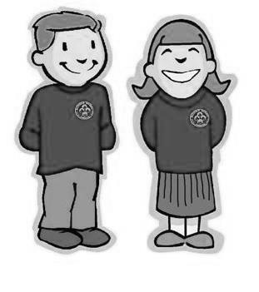
Scenario 12:  Your friend keeps emailing/messaging you every time you are online and its getting really annoying. | 
Scenario 13:  You have a Facebook account and you’re under 13. You don’t want it anymore. | 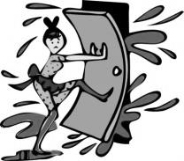
Scenario 14:  You can’t stop playing computer games until really late every night. | 
Scenario 15:  You told your friend your password and now they’ve used your account to send mean messages. | 

